University of Computer and Emerging Sciences



Laboratory Manual
for

Web Engineering Lab

Course Instructor | Sir Mudassir Saeed
Lab Instructor | Marwa Khan
Section | BSE-6A
Semester | Spring 2024

Department of Computer Science
FAST-NU, Lahore, Pakistan

Objective(s):
- To understand the basic concepts web engineering.
- To understand the basic concepts of HTML and realize the presentation of a web page using different tags.
- Understanding of distribution of text in table.

Lab Tasks:

Task 01:
The objective of this lab task is to learn how to implement a hyper link and how to insert an image on a web page.

- Create New HTML Page
- Add Paragraphs
- Make some content of paragraph as Bold, Italic and Underline
- Different font sizes
- Make a new three paragraphs and align them to Right, left and center alignments
- Insert a hyper link.
- Insert an image.
- Display in the browser

Task 02

- Apply Heading one, heading three and Heading 5
- Add 8 Different Meta Tags
- Create Basic List with your educational details

Task 03:
- Implement a nested list.
- Implement a complex table.

Sample Output:

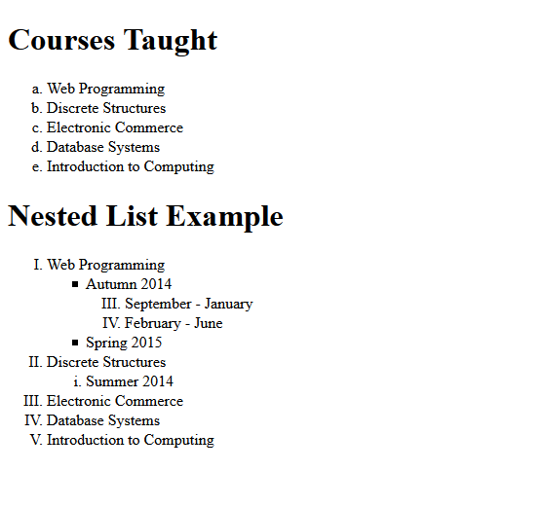

Task 04:
Make given below invoice using html table.

